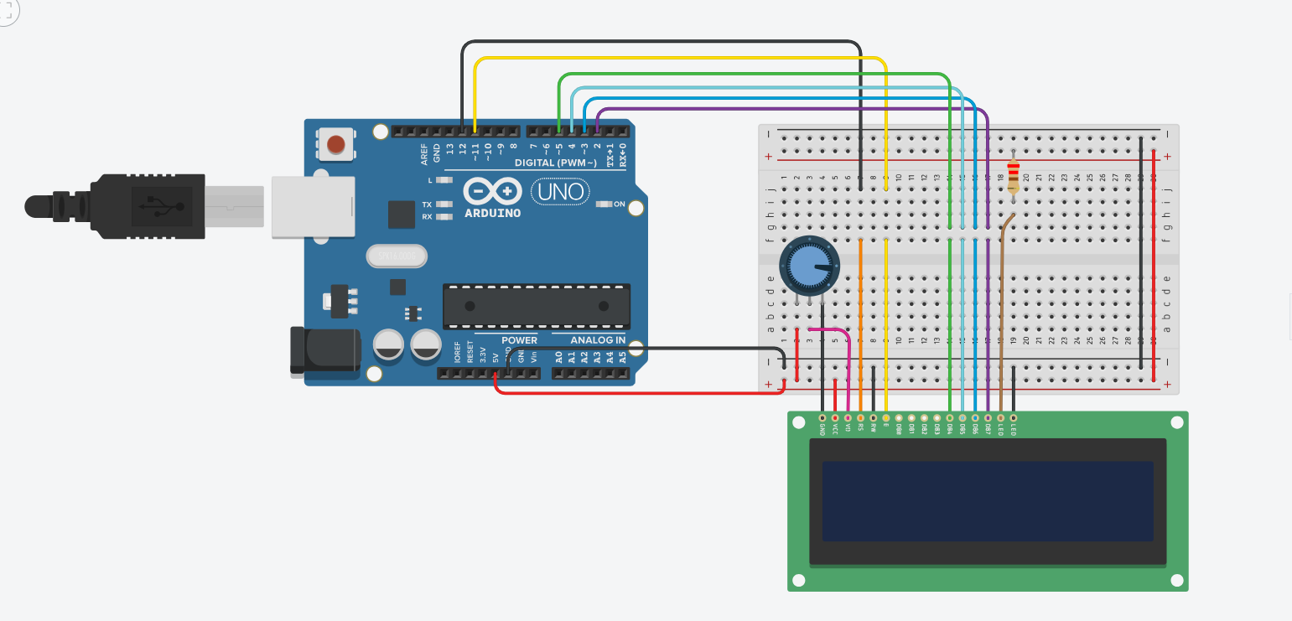

**CODE:**

#include <LiquidCrystal.h>

float temp;

int sensor = A0;

float tempc;

float tempf;

LiquidCrystal lcd (12, 11, 5, 4, 3, 2);

//The instance of the LiquidCrystal lcd shows LCD pins connected to the Arduino digital outputs.

void setup () {

// set the number of columns and the number of lines of lcd

lcd.begin (16, 2);

}

void loop () {

temp=analogRead(sensor);

//Read analog voltage from sensor and store it in a temporary float variable.

tempc=(temp*4.88)/10;

//This line converts float value into °C.

tempf=(tempc*1.8)+32;

//This line converts °C into Fahrenheit.

lcd.setCursor(0,0);

lcd.print("Temp in C = ");

lcd.println(tempc);

//These two lines print Temperature value in °C.

lcd.setCursor(0,1);

lcd.print("Temp in F = ");

lcd.println(tempf);

//Above two lines print value in Fahrenheit

}

**OUTPUT DEMONSTRATION:**

